Stakeholders

Applicant:

An applicant’s goal is to become an accepted student in order to participate in the after-school learning program and must be able to submit an application.

Admin:

An Admin’s goal is to administer the system from a high level. Must be able to review and approve student applications. Must be able to add students, instructors, and social workers into the system, as well as update them and delete them from the system.Must be able to track feedings the school has provided.

Instructor:

An Instructor’s goal is to record their students’ attendance and assessment results and must be able to record attendance for each of their students, add their students’ assessment results to the system, award certificates to students, and attach student assets for sponsors to view.

Social Worker:

A Social Worker’s goal with the application is to manage their students schedule and monitor their social situation in order to ensure their students’ best chance at success in the program and must have record of their students’ attendance, be able to create a record of social history and notes for their students (as well as read, update, and delete those records), and create a schedule of classes that works for their students (also read, update, and delete those schedules).

Owner / Board of Directors:

The Board of Directors’ goal is to monitor the current students’ academic performance in order to determine how successful the SMART School has been for each student and must be able to generate a report of the students’ academic performance and their social notes / history.

USA Sponsor:

A USA Sponsor’s goal is to monitor the academic performance of the student(s) they sponsor and must be able to generate a report of the academic performance, social notes / history, and student assets for the students they sponsor. They must also be able to sponsor students.

User Stories

Applicant:

* As an applicant, I want to submit an application to the SMART system, so that I can be enrolled in the after-school learning program.

Admin:

* As an admin, I want to review and approve an applicant’s application, so that they can be enrolled as a student in the system.
* As an admin, I want to see a list of all students enrolled in the program, so that I can see all our students and their data.
* As an admin, I want to see all the classes that a student is in, so that I can track which classes they are taking.
* As an admin, I want to update a student’s data, such as their address or contact information, so that the system’s records maintain up-to-date data.
* As an admin, I want to update a student’s status, so that the system tracks whether a student is active, graduated, or has been removed from the program.
* As an admin, I want to add new instructors to the system, so that the system has a record of all instructors in the program.
* As an admin, I want to see a list of all instructors in the system, so that I can see all the instructors we have and their data.
* As an admin, I want to see a list of an instructor’s classes, so that I can track which classes they are teaching.
* As an admin, I want to see a list of all students in a class, so that I can track which students are in a particular class.
* As an admin, I want to update an instructor’s data, such as their address or contact information, so that the system’s records maintain up-to-date data.
* As an admin, I want to disable an instructor’s account, so that instructors who are no longer part of the program cannot access the system.
* As an admin, I want to add new social workers to the system, so that the system has a record of all social workers in the program.
* As an admin, I want to see a list of all social workers in the system, so that I can see all the social workers we have and their data.
* As an admin, I want to update a social worker’s data, such as their address or contact information, so that the system’s records maintain up-to-date data.
* As an admin, I want to disable a social worker’s account, so that social workers who are no longer part of the program cannot access the system.
* As an admin, I want to set up USA sponsor accounts (manual), so that our students are able to have financial sponsors
* As an admin, I want to view a list of all USA Sponsors and the students they sponsor, so I can track who is sponsoring who.
* As an admin, I want to edit USA sponsor accounts, so that their data remains up-to-date
* As an admin, I want to disable USA sponsor accounts, so that sponsors who are no longer working with the program cannot access the system
* As an admin, I want to set up Board of Director accounts, so that our Board of Directors can access the system
* As an admin, I want to view a list of all Board of Director accounts, so that I can track who is on the Board of Directors in the system
* As an admin, I want to edit Board of Director accounts, so that their data remains up-to-date
* As an admin, I want to disable Board of Director accounts, so that Board of Director members who are no longer working with the program cannot access the system
* As an admin, I want to record student feedings, so that I can keep track of how many times a particular student has been fed by the program.

Instructor:

* As an instructor, I want to record my students’ attendance, so that I can keep track of attendance.
* As an instructor, I want to edit a student’s attendance record, so that I can correct a mistake in the recorded attendance.
* As an instructor, I want to record my students’ assessment results in the system with notes, so that the system has a record of each students’ scores.
* As an instructor, I want to see a list of all my students and their assessment scores, so that I can keep track of my students’ grades.
* As an instructor, I want to update one of my student’s assessment scores, so that I can correct any issues there may be in the recorded grade.
* As an instructor, I want to issue certificates to my students, so that they can move onto the next level after demonstrating proficiency.
* As an instructor, I want to pull up a printable page of a certificate, so that I can print it for my students.
* As an instructor, I want to attach student assets to my students in the system, so that their USA Sponsors can view them.
* As an instructor, I want to create classes, so that I have classes to teach
* As an instructor, I want to assign class schedules to students, so that I can figure out which of my classes will fit best between their public school schedules.
* As an instructor, I want to update a student’s class schedule, so that if a situation arises or circumstances change the schedule will still work for the student.

Social Worker:

* As a social worker, I want to view all student attendance records, so that I can follow up with students who may be struggling to attend.
* As a social worker, I want to record history and notes of a student’s social situation, so that the system has a record of the student’s circumstances.
* As a social worker, I want to update a student’s social history or notes, so that the information contained therein remains up-to-date and accurate.
* As a social worker, I want to view a list of students and their class schedules, so that I can keep track of which students have which classes.
* As a social worker, I want to view a printable page of a student’s schedule, so that I can print it for them.

Owner / Board of Directors:

* As a member of the Board of Directors, I want to view a report of all students’ academic performances, their social history and notes from their social worker, so that I can keep track of how well students are doing in the program.
* As a member of the Board of Directors, I want to view a report of the statistical breakdown of student English and IT levels, so that I can monitor the statistics of the program’s curriculum.

USA Sponsor:

* As a USA Sponsor, I want to view a report of my sponsored students’ academic performances, their social history and notes from their social worker, and their student assets, so that I can keep track of how well my sponsored students are doing.

Use Case Diagram

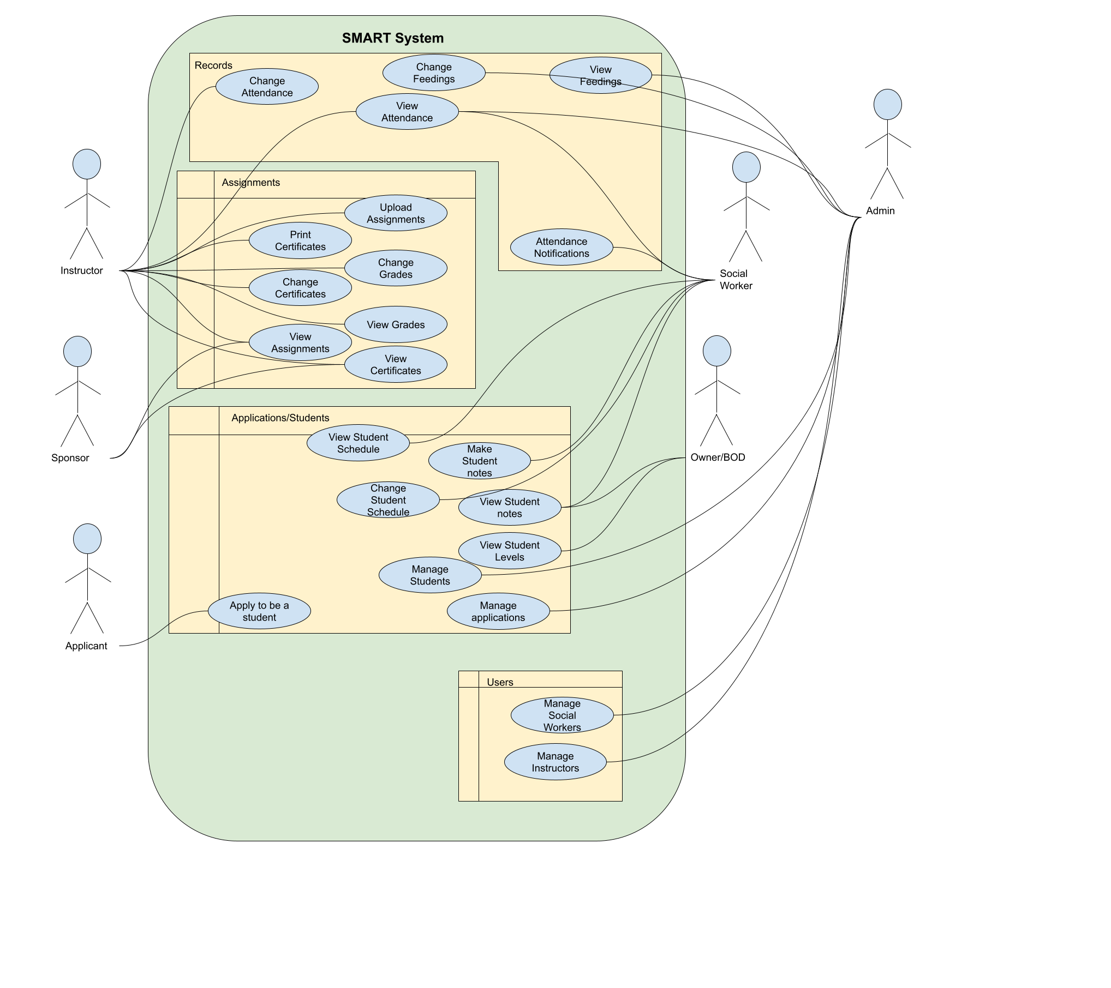

Activity Diagrams

Admin reviews application

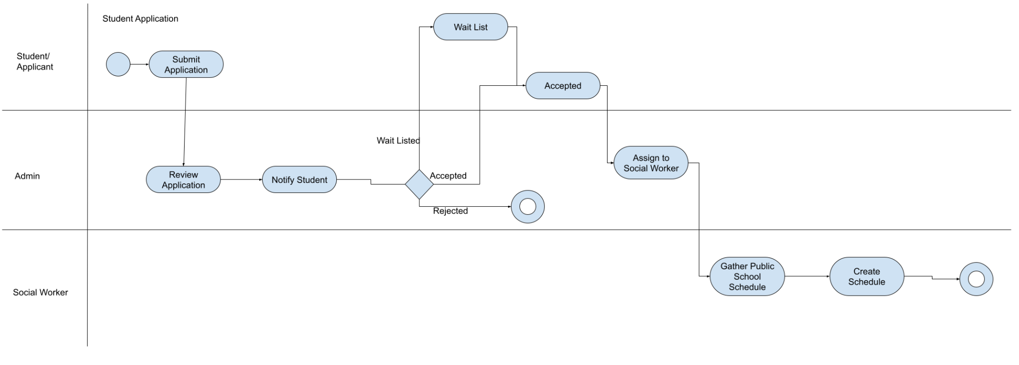

Instructor marks attendance

